**JSP Login Logout Example**

In this section we will discuss how to create a simple login and logout example

**In this section we will discuss how to create a simple login and logout example**

**JSP Login Logout Example**

In this section we will discuss how to create a simple login and logout example.

This section will describe you all the steps for creating a simple login and logout example. To create a simple login logout example in JSP we will use Eclipse IDE for compile and Tomcat 7 server for deploying the application.

In this application we will fetch the record from database and then matched them to the input value that are given through the user interface i.e. login form.

**Example**

I am giving here a simple login logout example. We will create this example using JSP. In this example we will take input through a form and we will validate the input record from the record saved into the database table. For this at first we will create a database table and then we will insert some dummy values. Then we will create the JSP pages for different purposes. At first we will create **home.jsp** page where we will design an interface for the user to input and submit their records then we will create **login.jsp** page where we will write the code for getting the input field values and the database table records. Here we will write the sql query for fetching the matched record from table. Then we will create **welcome.jsp** page where we will write the code for showing the valid user name after the value matched. Then we will create **error.jsp** page where we will write the code for showing the error message after if any problem getting in login to the user. Then finally we will create logout.jsp page where we will write the code for logout of user from the application. In this example we will use the JSP implicit object session and we will use the methods setAttribute() for setting the attribute value in session and getAttribute() method for getting the attribute value from the same session invalidate() method for ending the session or logout from the application.

**Here is the video tutorial that explains you how to create JSP Login form backed with MySQL database.**

**Database Table**

**userdetail**

CREATE TABLE `userdetail` (

`id` int(5) NOT NULL,

`name` varchar(20) DEFAULT NULL,

`password` varchar(35) DEFAULT NULL,

`usertype` varchar(30) DEFAULT NULL,

PRIMARY KEY (`id`)

) ENGINE=InnoDB DEFAULT CHARSET=latin1

**Insert values into the table**

insert into `userdetail`(`id`,`name`,`password`,`usertype`) values ( '1','arun','arun','admin')

insert into `userdetail`(`id`,`name`,`password`,`usertype`) values ( '2','deepak','deepak','user')

**Values in the table**

https://www.roseindia.net/tutorialfiles/48175.table.gif

**Directory Structure of application**

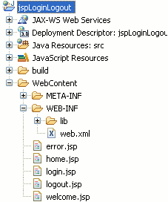

**JSP Code**

**home.jsp**

<%@ page language="java" contentType="text/html; charset=ISO-8859-1"

pageEncoding="ISO-8859-1"%>

<%@ page import="java.sql.*" %>

<!DOCTYPE html PUBLIC "-//W3C//DTD HTML 4.01 Transitional//EN" "http://www.w3.org/TR/html4/loose.dtd">

<html>

<head>

<meta http-equiv="Content-Type" content="text/html; charset=ISO-8859-1">

<title>Home</title>

</head>

<body>

<%

Connection con= null;

PreparedStatement ps = null;

ResultSet rs = null;

String driverName = "com.mysql.jdbc.Driver";

String url = "jdbc:mysql://localhost:3306/record";

String user = "root";

String password = "root";

String sql = "select usertype from userdetail";

try {

Class.forName(driverName);

con = DriverManager.getConnection(url, user, password);

ps = con.prepareStatement(sql);

rs = ps.executeQuery();

%>

<form method="post" action="login.jsp">

<center><h2 style="color:green">JSP Login Example</h2></center>

<table border="1" align="center">

<tr>

<td>Enter Your Name :</td>

<td><input type="text" name="name"/></td>

</tr>

<tr>

<td>Enter Your Password :</td>

<td><input type="password" name="password"/></td>

</tr>

<tr>

<td>Select UserType</td>

<td><select name="usertype">

<option value="select">select</option>

<%

while(rs.next())

{

String usertype = rs.getString("usertype");

%>

<option value=<%=usertype%>><%=usertype%></option>

<%

}

}

catch(SQLException sqe)

{

out.println("home"+sqe);

}

%>

</select>

</td>

</tr>

<tr>

<td></td>

<td><input type="submit" value="submit"/></td>

</table>

</form>

</body>

</html>

**login.jsp**

<%@ page language="java" contentType="text/html; charset=ISO-8859-1"

pageEncoding="ISO-8859-1"%>

<%@ page import="java.sql.*" %>

<!DOCTYPE html PUBLIC "-//W3C//DTD HTML 4.01 Transitional//EN" "http://www.w3.org/TR/html4/loose.dtd">

<html>

<head>

<meta http-equiv="Content-Type" content="text/html; charset=ISO-8859-1">

<title>Login</title>

</head>

<body>

<%! String userdbName;

String userdbPsw;

String dbUsertype;

%>

<%

Connection con= null;

PreparedStatement ps = null;

ResultSet rs = null;

String driverName = "com.mysql.jdbc.Driver";

String url = "jdbc:mysql://localhost:3306/record";

String user = "root";

String dbpsw = "root";

String sql = "select * from userdetail where name=? and password=? and usertype=?";

String name = request.getParameter("name");

String password = request.getParameter("password");

String usertype = request.getParameter("usertype");

if((!(name.equals(null) || name.equals("")) && !(password.equals(null) || password.equals(""))) && !usertype.equals("select"))

{

try{

Class.forName(driverName);

con = DriverManager.getConnection(url, user, dbpsw);

ps = con.prepareStatement(sql);

ps.setString(1, name);

ps.setString(2, password);

ps.setString(3, usertype);

rs = ps.executeQuery();

if(rs.next())

{

userdbName = rs.getString("name");

userdbPsw = rs.getString("password");

dbUsertype = rs.getString("usertype");

if(name.equals(userdbName) && password.equals(userdbPsw) && usertype.equals(dbUsertype))

{

session.setAttribute("name",userdbName);

session.setAttribute("usertype", dbUsertype);

response.sendRedirect("welcome.jsp");

}

}

else

response.sendRedirect("error.jsp");

rs.close();

ps.close();

}

catch(SQLException sqe)

{

out.println(sqe);

}

}

else

{

%>

<center><p style="color:red">Error In Login</p></center>

<%

getServletContext().getRequestDispatcher("/home.jsp").include(request, response);

}

%>

</body>

</html>

**welcome.jsp**

<%@ page language="java" contentType="text/html; charset=ISO-8859-1"

pageEncoding="ISO-8859-1"%>

<!DOCTYPE html PUBLIC "-//W3C//DTD HTML 4.01 Transitional//EN" "http://www.w3.org/TR/html4/loose.dtd">

<html>

<head>

<meta http-equiv="Content-Type" content="text/html; charset=ISO-8859-1">

<title>Welcome</title>

</head>

<body>

<p>Welcome, <%=session.getAttribute("name")%></p>

<p><a href="logout.jsp">Logout</a>

</body>

</html>

**error.jsp**

<%@ page language="java" contentType="text/html; charset=ISO-8859-1"

pageEncoding="ISO-8859-1"%>

<!DOCTYPE html PUBLIC "-//W3C//DTD HTML 4.01 Transitional//EN" "http://www.w3.org/TR/html4/loose.dtd">

<html>

<head>

<meta http-equiv="Content-Type" content="text/html; charset=ISO-8859-1">

<title>Login Error</title>

</head>

<body>

<center><p style="color:red">Sorry, your record is not available.</p></center>

<%

getServletContext().getRequestDispatcher("/home.jsp").include(request, response);

%>

</body>

</html>

**logout.jsp**

<%@ page language="java" contentType="text/html; charset=ISO-8859-1"

pageEncoding="ISO-8859-1"%>

<!DOCTYPE html PUBLIC "-//W3C//DTD HTML 4.01 Transitional//EN" "http://www.w3.org/TR/html4/loose.dtd">

<html>

<head>

<meta http-equiv="Content-Type" content="text/html; charset=ISO-8859-1">

<title>Logout</title>

</head>

<body>

<% session.invalidate(); %>

<p>You have been successfully logout</p>

</body>

</html>

**Output**

When you will compile and deploy this example using Eclipse and Tomcat 7 then the output will be as follows :

1. Home page will be looked as follows :

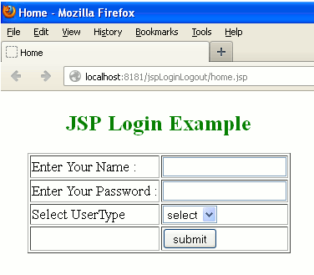

2. When you will enter the value and if it matched from the corresponding database table value then the output will be as follows :

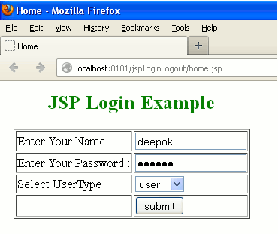

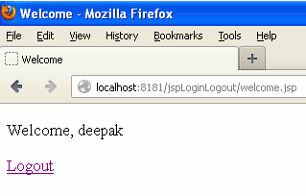

3. When you will click on the link for logout then the output will be as follows :

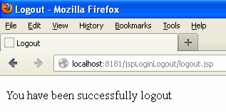

4. But, when you will incorrect value in the respective fields then the output will be as follows :

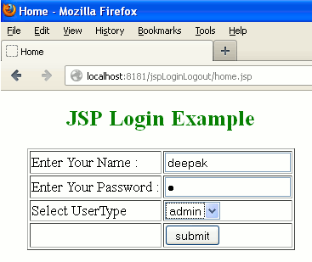

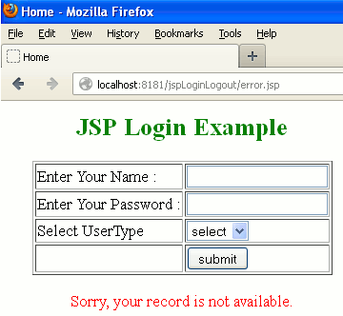

5. If you left the any field empty or if you don't select the usertype then the output will be as follows :

